create database Sentiment_analysis;

use sentiment_analysis;

select * from `dataset sentiment`;

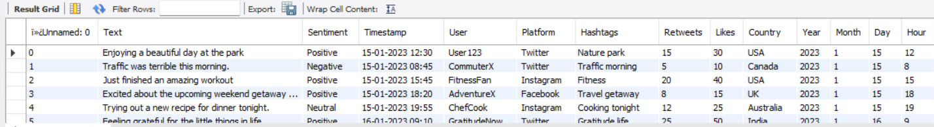

SELECT Sentiment, COUNT(*) AS Count

**1. Sentiment Analysis**

To get a count of each sentiment category:

SELECT Sentiment, COUNT(*) AS Count

FROM `dataset sentiment`

GROUP BY Sentiment

ORDER BY Count DESC;

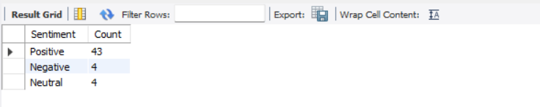

**2. Temporal Analysis**

To analyze the number of posts over time (e.g., by month):

SELECT YEAR(Timestamp) AS Year, MONTH(Timestamp) AS Month, COUNT(*) AS PostCount

FROM `dataset sentiment`

GROUP BY YEAR(Timestamp), MONTH(Timestamp)

ORDER BY Year, Month;

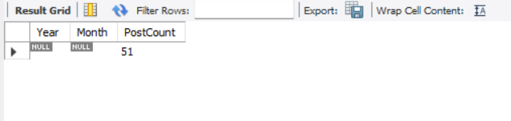

**3. User Behavioural Insights**

To analyze average likes and retweets per sentiment:

SELECT Sentiment, AVG(Likes) AS AvgLikes, AVG(Retweets) AS AvgRetweets

FROM `dataset sentiment`

GROUP BY Sentiment

ORDER BY AvgLikes DESC;

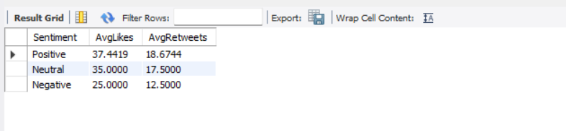

**4. Platform-Specific Analysis**

To compare sentiments across different platforms:

SELECT Platform, Sentiment, COUNT(*) AS Count

FROM `dataset sentiment`

GROUP BY Platform, Sentiment

ORDER BY Platform, Count DESC;

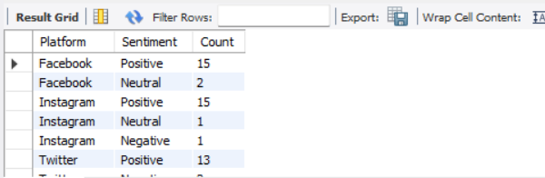

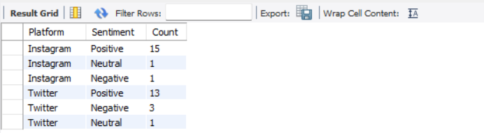

**5. Hashtag Trends**

To find the most common hashtags used:

SELECT Hashtags, COUNT(*) AS Count

FROM `dataset sentiment`

WHERE Hashtags IS NOT NULL AND Hashtags != ''

GROUP BY Hashtags

ORDER BY Count DESC

LIMIT 10; -- Adjust the limit as needed

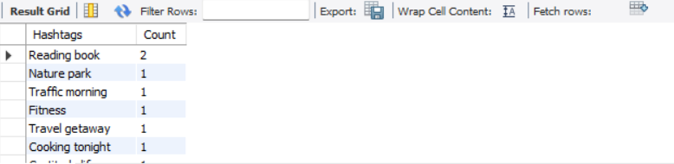

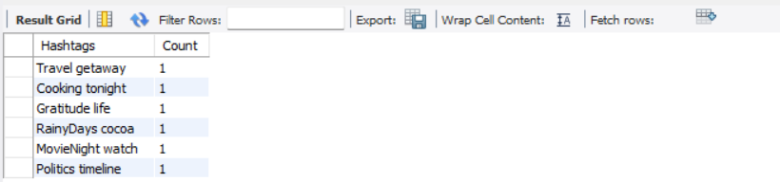

**6. Geographical Analysis**

To analyze sentiment distribution by country:

SELECT Country, Sentiment, COUNT(*) AS Count

FROM `dataset sentiment`

GROUP BY Country, Sentiment

ORDER BY Country, Count DESC;

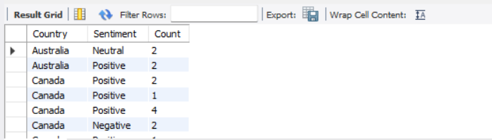

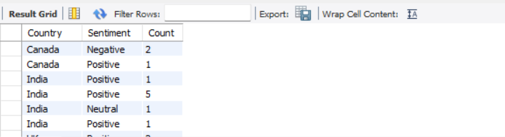

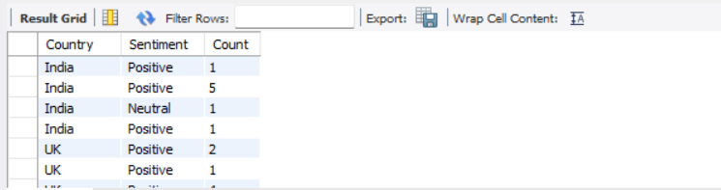

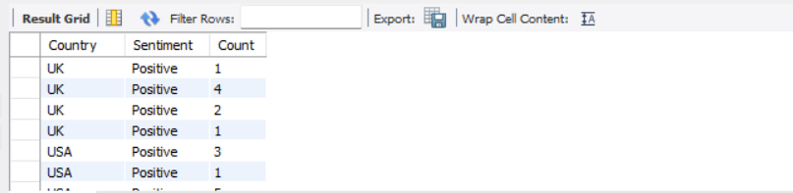

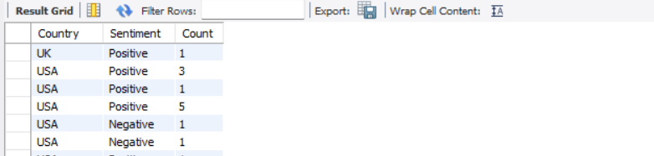

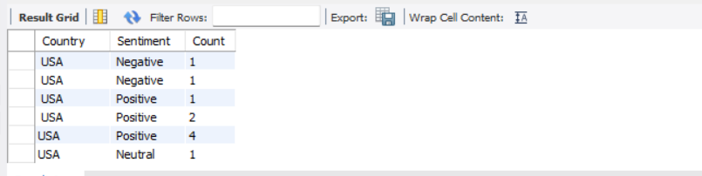

**7. User Identification**

To track contributions of specific users:

SELECT User, COUNT(*) AS PostCount, AVG(Likes) AS AvgLikes, AVG(Retweets) AS AvgRetweets

FROM `dataset sentiment`

GROUP BY User

ORDER BY PostCount DESC

LIMIT 10; -- Top 10 users

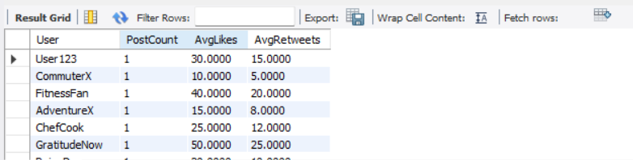

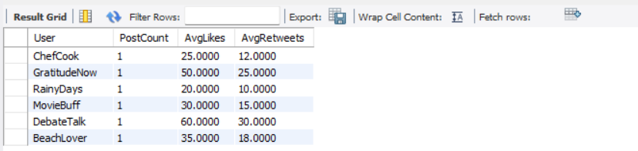

**8. Cross-Analysis**

To analyze sentiment trends over time by platform:

SELECT YEAR(timestamp) AS Year, MONTH(timestamp) AS Month, Platform, Sentiment, COUNT(*) AS Count

FROM`dataset sentiment`

GROUP BY YEAR(timestamp), MONTH(timestamp), Platform, Sentiment

ORDER BY Year, Month, Platform, Count DESC;

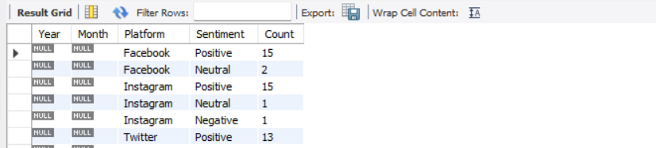

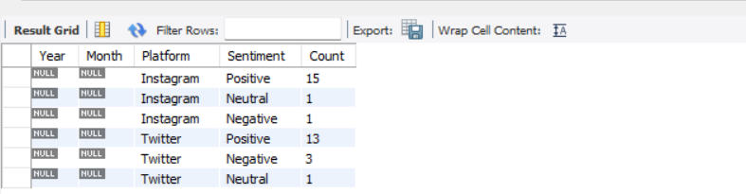

**Description of the Sentiment Analysis Project**

* **Project Overview:**
  + Developed a **Sentiment Analysis Project** utilizing a dataset sourced from **Kaggle** to analyze social media sentiments, focusing on user interactions and emotional responses.
* **Data Preparation:**
  + **Cleaned** the dataset in **MS Excel** to ensure data quality and consistency before analysis.
  + Created a **database** named **Sentiment_analysis** and established a table called **sentiment_data** with **3 columns**:
    - **id** (INT)
    - **text** (TEXT)
    - **sentiment** (VARCHAR(10))
* **Data Analysis Techniques:**
  + **Sentiment Analysis:**
    - Conducted sentiment classification on the **"Text"** column, categorizing user-generated content into various emotional states such as **surprise**, **excitement**, **admiration**, **thrill**, and **contentment**.
  + **Temporal Analysis:**
    - Analyzed trends over time using the **"Timestamp"** column to identify patterns and fluctuations in social media content.
  + **User Behavior Insights:**
    - Evaluated user engagement metrics through the **"Likes"** and **"Retweets"** columns to discover popular content and user preferences.
  + **Platform-Specific Analysis:**
    - Examined sentiment variations across different social media platforms using the **"Platform"** column to understand how sentiments differ by platform.
  + **Hashtag Trends:**
    - Identified trending topics by analyzing the **"Hashtags"** column, uncovering popular or recurring hashtags within the dataset.
  + **Geographical Analysis:**
    - Explored content distribution based on the **"Country"** column to understand regional variations in sentiment and topic preferences.
  + **User Identification:**
    - Tracked specific users and their contributions using the **"User "** column, analyzing the impact of influential users on sentiment trends.
  + **Cross-Analysis:**
    - Combined multiple features for in-depth insights, such as analyzing sentiment trends over time or across different platforms and countries.
* **Results:**
  + The analysis provided comprehensive insights into the emotional landscape of social media, revealing key trends and user behaviors.
  + Generated actionable insights that can inform marketing strategies, content creation, and user engagement initiatives.
* **Conclusion**

In this project, we explored the application of sentiment analysis to understand public opinion and emotional tone in textual data. Our findings indicate that sentiment analysis can provide valuable insights into consumer behaviour, social media trends, and public sentiment regarding specific topics or events.

Moreover, we identified key challenges in sentiment analysis, such as the handling of sarcasm, context, and the nuances of language.

Overall, this project highlights the significance of sentiment analysis in today’s data-driven world and its potential applications across various industries, including marketing, finance, and public relations.